MEDICAL ASSISTANCE – ANYTIME - ANYWHERE

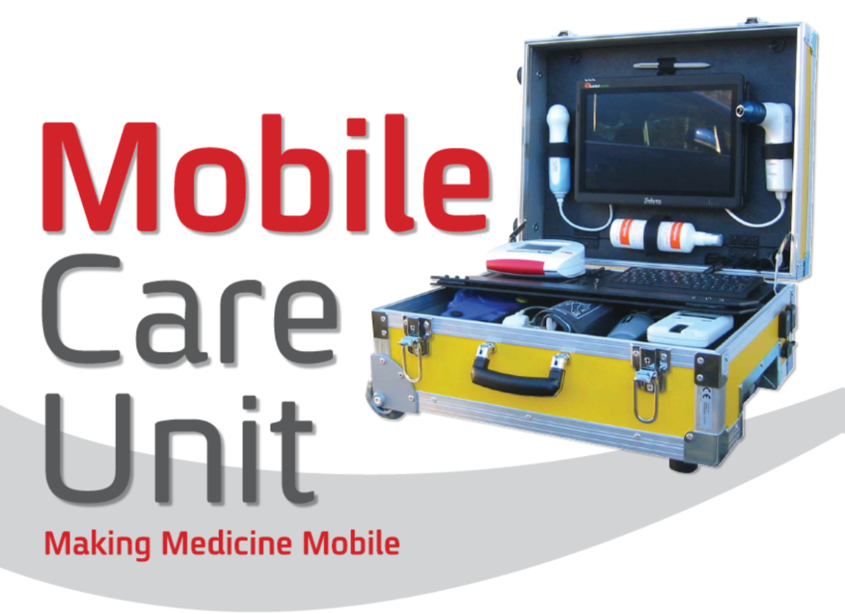

The MCU or Mobile Care Unit is the only portable medical kit system which offers Ultra Sound (examine for internal damage, broken bones, heart, pregnancy) and Orthoscopic (examine ears, nose, throat) plus many more options. .
The pictures (both video and still) can be sent to your medical center in real-time for instant observation and analysis. In addition the MCU allows for both urine and blood samples.
The “user” don’t need to have a medical background then the “user” can be directed by the doctors on the other side. Video makes it very easy for the doctor to have the “on-site feeling”. The MCU screen allows for both sides to see 3 windows (1 of the patient, 1 of the doctor and 1 of the exam pictures/video being sent). All exams are done by pressing the icon on the PC screen.

The MCU then does the exam automatically and sends the results in real-time to your medical center and/or other doctors or specialists any place in the world via all forms of telecommunication (Satellite, LAN, WLAN, 3G, WIFI, PSTN). All examination information is sent in real time. If there is no connection then the information is saved in the MCU and can be sent later. The size of the data transmitted is very small, much like a few words written for a text message.

The MCU is a portable, fully automatic, robust system which allows you to do a complete physical examination (Ultra Sound, Orthoscopic, ECG, Non-Invasive Blood Pressure, Spirometry/Lung Capacity, Pulse Oximetry/SPO2 with more) onsite anyplace in the world. It allows anyone, even with very little medical knowledge to perform a complete medical examination according to instruction from the doctor via “telemedicine”.

All examination functions in the MCU are fully automatic.
In regards to the ECG you only need to place the ECG reader box on the patient’s chest and
it is not a lot of cables with sticky tape which need to be correctly placed.
This is ideal if you just have used the defibrillator in the MCU kit and needs to monitor the patient’s situation.

The MCU is capable to automatically perform the following functions:

1. Ultrasound (to examine for broken bones, heart or internal bleeding)
2. Orthoscopic (for ear, nose, throat exams)
3. NIBP - Blood pressure which is performed and read automatically
4. ECG - heartbeat, NO adhesive sensors, with a lot of wires, are necessary
5. Defibrillator (Heart Starter)
6. SPIRO - measurement of the lungs capacity
7. SPO2 – measurement of oxygen in blood
8. Other analyses and tests (blood glucose, cholesterol, urine analysis, vision,
hearing)
9. Test of Malaria, HIV, Hepatitis
10. A Camera allows for real time visual examinations

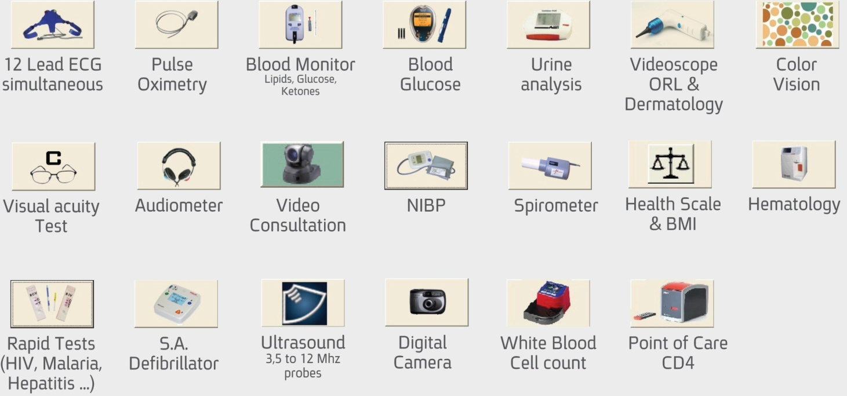

Menu from the computer screen

The MCU can be delivered in a suitcase showed in the picture or build into a cabinet in a Van like Mercedes Sprinter or similar car together with an examination table, small office and other equipment if wanted as a complete and fully Mobile Clinic with its own laboratory.

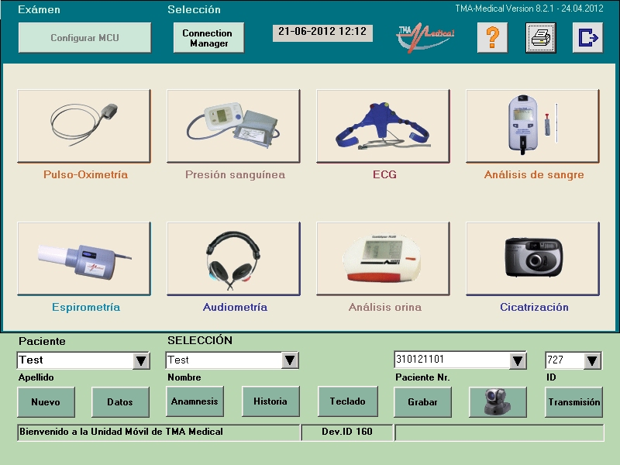

The software can be delivered in different languages.

This system is amongst many other areas a very good solution for countries with lack of medical services in one or another way to quickly solve the “top” of the problems in a cheap and easy way. If you set up a central with specialists within the different areas, they can support many teams at the same time in the field. Only patient’s with “really” need of medical treatment and/or surgery in a hospital need to be brought in.

If you already have hospitals and clinics/healthcare centers in your country, but with missing equipment and/or doctors and nurses, set up an examination clinic each place connected to one or more centrals with medical specialists. If you are lack of hospitals and clinics too, set up the necessary numbers of mobile clinics to go around in areas which need this kind of services. In this case we can also offer semi-permanent hospital ready to use after some few months any places in the world including management and all kind of necessary staff if needed.

The MCU is also perfect onboard in ships, oil installations and platforms, any kind of plants with many workers and much, much more.

Normeca can offer complete packages including management, medical specialists and other necessary staff to run the operation during the time we are training your local staff to take over the operation after an agreed period of time. Please contact us today for more information and an informal offer.

